## horizontal line

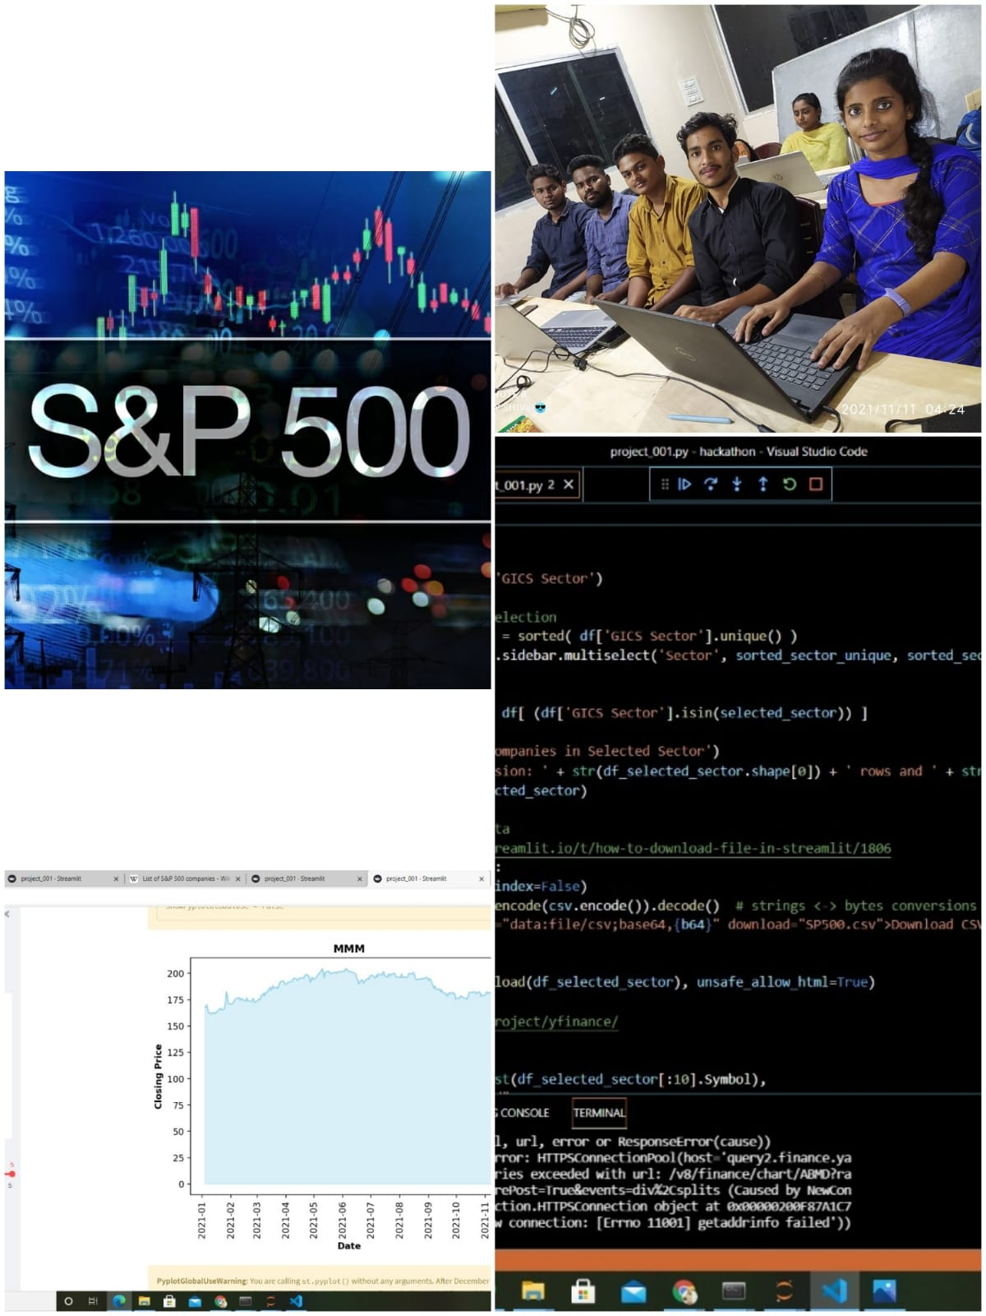

S&P 500 APP

11-11-2021

**─**

TEAM 15

TEAM LEAD-JOSHUVA

TEAM MEMBERS-KEERTHI ,SIVA RAMA KRISHNA,

DHILEEP ,CHARAN TEJA

KIET HACKTHON 2021

KORANGI,KAKINADA

# Overview Of project

Stock marketing is one of the greatest trending today.A stock may be bought or sold only if it is listed on an exchange.It is a place where shares of public listed companies are traded. We created the app to easily visualize the list of the s&p 500 and its corresponding stock closing price(year-to-date)!

# Goals

1. To learn about the project building,team building,and also how efficiency the code run,and making the dashboard.
2. We have to exhibit the code with the perfection ,and we have to search and gain the knowledge and have to improve our technical skills.

**STEPS FOLLOWED DURING THE PROJECT**

1.We imported streamlit and imported libraries(pandas,base64,matplotbin ,seaborn)

2.In the vs code platform,we started executed the title using streamlit, and worked on sidebar header, and started collection of data from kaggle(google)

3.we write the code for filtering data,adjustments for dataframe,and also worked on file download using streamlit markdown

4.Finally the data was entered and dashboard is finalized.

# ]Milestones

ERRORS

Failure is the stepping stone to success as errors make us to improve the success of code.It definitely improves the grip on that programming language..

**Github**

<https://github.com/Chinthajoshuva/Team_15_KIET.git>

<https://github.com/Chinthajoshuva/Team_15_KIET/commit/42f802ccc07eb616f9998f563f441778e0a1dd30>

**Linkedin**

[**https://www.linkedin.com/posts/keerthi-korumilli-51580a204_learning-knowledgeispower-kiet-activity-6864344219683753984-r25s**](https://www.linkedin.com/posts/keerthi-korumilli-51580a204_learning-knowledgeispower-kiet-activity-6864344219683753984-r25s)

